25.52: From Eq. (25.24), 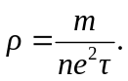
b) The number of free electrons in copper 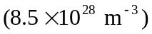 is much larger than in pure silicon 